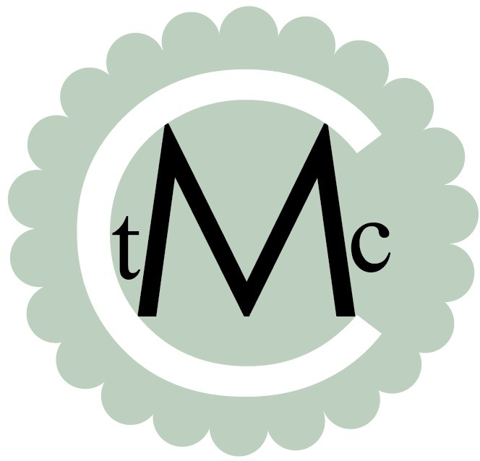
TANIA McCARTNEY
author editor reviewer

29 July 2013

To: The Australian Law Reform Commission

Review Committee of Copyright and the Digital Economy

Dear Commissioners,

My name is Tania McCartney and I am an author of both children’s and adult books, as well as an experienced publisher and editor. I’m a past Ambassador for the National Year of Reading 2012, and am also the Founder of Kids’ Book Review, the most respected children’s literature site on the web.

I develop educational and entertainment resources using my time, creative skills and knowledge, and my material is my intellectual property. I own the copyright to my material and I expect people who use it to pay for the time and effort I have expended on its creation. As a professional, not only do I expect to be paid but I rely on that payment as income.
The statutory licences the ALRC is recommending be repealed are very important to me. If my work is copied and shared by teachers in the classroom, I receive a copyright payment from the Copyright Agency.
These payments are recognition of the value of the material I have created, using my time, skill and experience. Just as a supplier sells paper to a school for use in a photocopier, or a retailer sells laptops to a school, my work facilitates education and mental and literacy development in children.

The system works very efficiently and quietly with very little administrative requirement from me, however, if the proposed change is made, how will I develop licensing arrangements myself? How will I track down copyright breaches? How will I prosecute breaches? How will I afford to mount a legal case on the scant wage I already receive? What compensation will I receive for loss of income, to mount legal challenges or for the time it takes me to administer licensing arrangements?
I am a specialist in my creative field. I have little expertise in the intricacies of Copyright Law, nor the time to pursue breaches – no matter how concerned I am or how it will affect my rights and income.
I reject the repeal of the very effective and fair Australian educational statutory licence system. Such a recommendation is a personal attack on my rights and the rights of the many impassioned people who keep the Arts afloat in this fabulous country. When creatives lose such rights, they lose their capacity to create such vital work.

It was once suggested to Winston Churchill that he cut funding to the arts to pay for Britain’s war, to which he responded “Then what would we be fighting for?”

Yours faithfully,

Tania McCartney

